**ARCH Primary Care Network**

**Patient Newsletter**

**August 2023**

**What is a Primary Care Network?**

Since the NHS was created in 1948, the population has grown and people are living longer. Many people are living with long term conditions such as diabetes and heart disease or suffer with mental health issues and may need to access their local health services more often.

To meet these needs, GP practices are working together with community, mental health, social care, pharmacy, hospital and voluntary services in their local areas in groups of practices known as primary care networks (PCNs).

PCNs build on existing primary care services and enable greater provision of proactive, personalised, coordinated and more integrated health and social care for people close to home. Clinicians describe this as a change from reactively providing appointments to proactively caring for the people and communities they serve.

Each of the 1,250 PCNs across England are based on GP registered patient lists, typically serving natural communities of between 30,000 to 50,000 people (with some flexibility). They are small enough to provide the personal care valued by both people and GPs, but large enough to have impact and economies of scale through better collaboration between GP practices and others in the local health and social care system.

PCNs are led by clinical directors who may be a GP, general practice nurse, clinical pharmacist or other clinical profession working in general practice.

**Who is in ARCH Primary Care Network (PCN)?**

ARCH PCN is 9 Practices from the Alfreton, Ripley, Crich and Heanor area. Our 9 Practices are:

* Crich Medical Practice - Ivy Grove Surgery
* Jessop Medical Practice - Kelvingrove Medical Centre
* Park Surgery - Parkside Surgery
* Somercotes Medical Centre - Ripley Medical Centre
* Royal Primary Care Brooklyn

Our vision is to deliver the needs of our population to improve health and wellbeing by providing access to a highly skilled, multi professional general practice workforce.

ARCH PCN works with Amber Valley Health Ltd to provide some of the extra healthcare services.

**What is Amber Valley Health Limited (AVH Ltd)?**

Amber Valley Health Limited is a group of seven Derbyshire Practices working together to provide extra healthcare services for the benefit of the local community.

The seven Practices are:

* Crich Medical Practice
* Ivy Grove Surgery
* Jessop Medical Practice
* Kelvingrove Medical Centre
* Park Surgery
* Parkside Surgery
* Somercotes Medical Centre

Working in collaboration with:

* Ripley Medical Centre
* Royal Primary Care Brooklyn

**What does AVH Ltd provide patients?**

Extended Access Service

AVH Ltd provides the extended access service on behalf of the Practices within ARCH PCN.

Appointments are available at Church Farm, Steeple Drive, Ripley – weekdays 6.00pm to 8.00pm and on a Saturday 9.00am to 5.00pm.

We have a mixture of face to face and telephone appointments available. Appointments should be booked through your own Practice. Please ask at your Practice if you specifically want to arrange one of these appointments.

More information can be found on ambervalleyhealth.com

**FLU CLINICS**

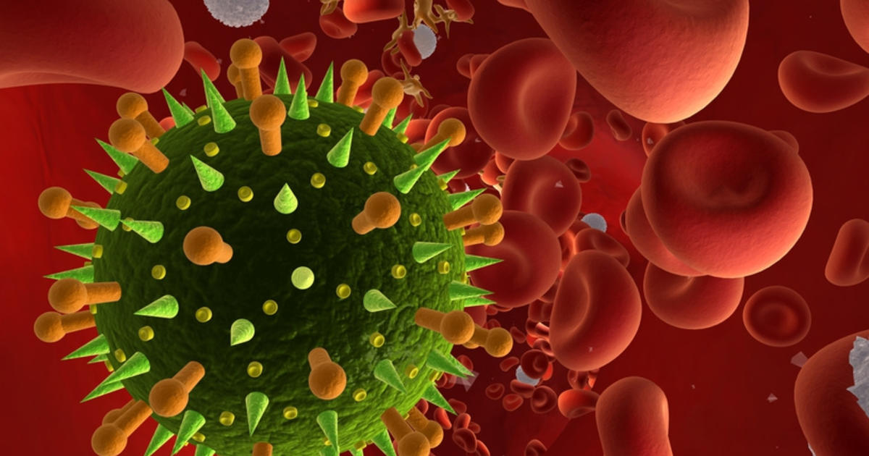

Please keep an eye out at your Practice or on their website for information on this years flu vaccination clinics. Practices are currently waiting for NHS guidance on the timings of these.

**Practice Closure Dates**

Practices will be closed from 13:30 on the following dates:

* 20 September 2023
* 18 October 2023
* 15 November 2023

**Please ring 111 if you need medical advice**

**NHS APP**

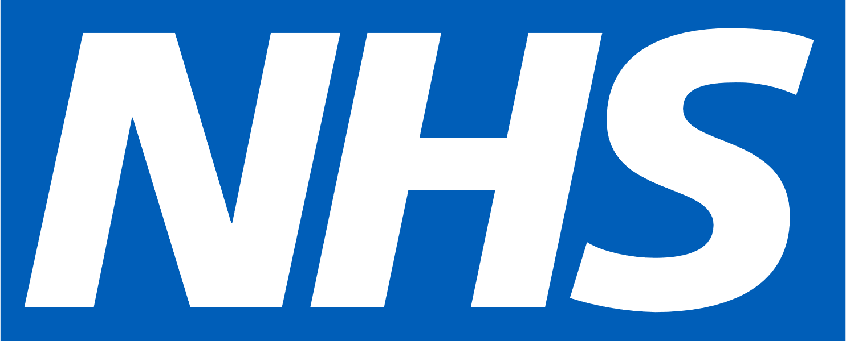

**Who is it suitable for?**

The NHS app is for people aged 13 and over

**How does it work?**

With the NHS app you can:

* Check your symptoms – find reliable NHS information on hundreds of conditions and treatments and get immediate advice
* Order repeat prescriptions – see your available medications and request a new repeat prescription
* View your medical record – get secure access to your GP medical record
* Register to be an organ donor – easily manage your preferences on the NHS Organ Donor Register
* Choose how the NHS uses your data – register your decision on whether it can be used for research and planning.

**How do I access it?**

You can access NHS App online by visiting [www.nhsapp.service.nhs.uk/login](https://www.nhsapp.service.nhs.uk/login)

The NHS App is free to download from the App Store and Google Play onto your mobile phones.

If you’re aged 16 and over, you can register for the NHS app without visiting the practice